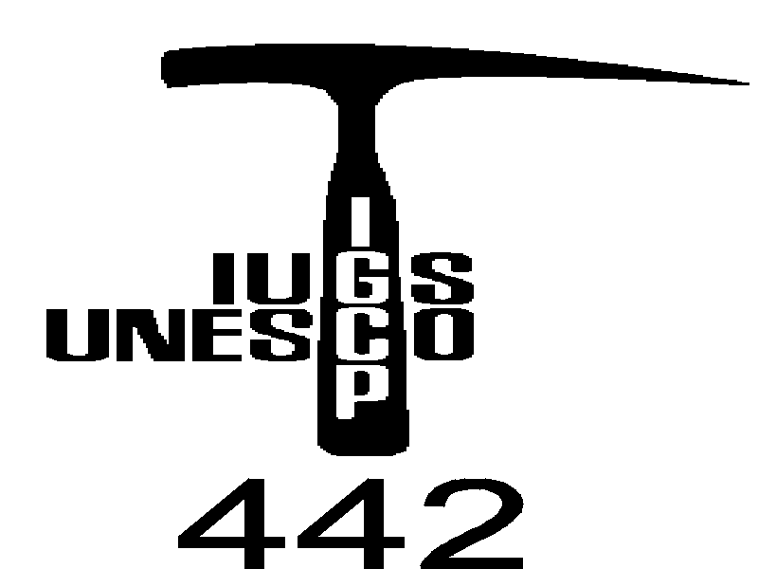

second Circular

„Udine and Genova 2001“

4th Workshop of the IGCP/UNESCO Project No. 442:
"Raw materials of the Neolithic/ Aeneolithic polished stone artefacts: their migration paths in Europe"

Meeting location
Udine and Genova, Italy, 24th – 28th September 2001
Accommodation
Accommodation will be reserved by organizer of the workshop on the base of your Accommodation Booking Form. Favorable solutions in hotels and/or hostels will be made known before next July, as well as possible further facilities.

Lodging
Location of lodging and the meeting venue (scheme and map) will be let known as above

Registration Fees
Full member: 40 EUR until 30.6.2001 and 50 EUR since 1.7.2001

Student member: 10 EUR until 30.6.2001 and 15 EUR since 1.7.2001

Registration fees include the organizational expenses and the Book of Abstracts
Method Of Payment
Bank transfer in EURO to
Bank: Slovenská sporiteľňa, a. s.
Slovak Republic (SWIFT: SLSPSKBX),
Account: 084830-6379445019
Details of payment: Project UNESCO/IGCP No. 442/PT 385
Correspondent bank American expres bank LTD, New York

Preliminary Program
September 24th, Monday, evening - Arrival to Udine. Accomodation. Night in Udine
September 25th Thuesday, Opening of workshop, relations, discussions.
Lectures:
Hovorka, D.: IGCP/UNESCO project 442 in its third year
Hovorka, D.: Where from are peculier raw material types used in Neolithic on territory of nowadays Slovakia?
Trnka, G.: Lower Bavarian Raw Materials along the River Danube to Eastern Austria
D΄Amico, C. & Starnini, E.: The polished stone axes workshop of Rivanazzano (PV-northern Italy): analyses of the lithological diversifies in comparison with other Italian Neolithic sites.
D’Amico C., Gasparotto G., Sabetta T.: Chalcolithic hammer axes in NE Italy and Slovenija.
Přichystal, A. & Trnka G.: Raw materials of Lengyel polished artefacts from Kamegg and Strass in Lower Austria
Dominguez Bella, S., Cantalejo, P., Espejo, Mª.M. & Ramos Muñoz, J.: Lithic resources in the prehistoric societies of the III-II mileniums B.C. in the Rio Turon valley (Ardales, Málaga, Spain)
Balen, J.: Polished stone artefacts from Sopot culture site Samatovci in Slavonia Region
Cheben, I. Hovorka, D. & Meres, Š.: Site Bajč – bonanza of raw material types (Neolithic, Slovakia)
Paunovic, M. & Matičec, D.: Origin and sources of raw material in Croatia
Józsa, S., Szakmány Gy., Oravecz H. & Csengeri P.: Preliminary Petrographic Report on Blueschist Neolithic Polished Stone Tools from Hungary
Prichystal, A.: Raw materials of polished artefacts from Bylany near Kutna Hora - key locality of Linear Pottery culture in Bohemia. ????
Kurtanjek, D., Balcu, D. R. & Balcu, J.: Petrological studies of Neolithic polished stone tools from Samatovci (Croatia).
Higgins M. D.: Jade in Greece
Gunia, P. & Prichystal, A.: Magnetic properties of Lower Silesian serpentinites and some serpentinite artefacts from SW Poland and Moravia.
Gunia, P. & Cholewa, P.: Serpentinites occurring of SW Poland as as potential raw material for production of the Neolithic artefacts
Přichystal, A. Greenschists in the Czech Republic as raw material for Neolithic/Aeneolithic polished artefacts
Schléder, Zs.,- Biró, K. T. & Szakmány, Gy.: Neolithic Phonolite mine and workshop complex in Hungary
Surmely, F. & Goër de Herve (A. de): Alpine eclogites and Jades polished axes in the Oenter and south-west of France.
Szakmány, Gy. & Kasztovszky, Zs.: Greenschist-amphibolite schist Neolithic polished stone tools in Hungary
Illášová, Ľ.: Basalts – raw material of stone artefacts of Neolithic and Aeneolithic cultures of Slovakia
Spišiak, J. Hovorka, D. & Méres, Š.: Clinopyroxene-rich metamorphic rocks: raw material of Neolithic implements found in Slovakia
K.T. Biró: Towards a comprehensive project webpage for IGCP-442
T. Težak-Greg l& M. Burić:The polished stone implements of the neolithic Starčevo Culture in Northern Croatia
Spišiak, J. & Hovorka, D.: High-pressure metabasites: seldom raw materal of the neolithic implements (Slovakia)
Hovorka, D. & Spišiak, J.: Neogene contact hornfelses: local raw material type of Neolithic implements from site Svodín (Slovakia)
Hovorka, D, Spišiak, J., Méres, Š., Dubíková, K. & Illášová, Ľ.: Simplectitic eclogite hammer-axe from the Nitriansky Hrádok site (Western Slovakia)
Late afternoon - Introduction to Neolithic and Copper Age Prehistory and Archaeopetrography in North-eastern Italy with particular attention to polished stone materials. Night in Udine.
September 26th, Wednesday, morning - Examination of Neolithic polished stones of eastern-Italy collections: green stones from NW Italy, local volcanic and sedimentary lithologies, some danubian serpentinite, silexite etc. artefacts, as well as dacite axes possibly of eastern provenance; Copper Age axes made from serpentinite, metamorphic ultramafite, amphybolites etc. of eastern Alps – Dinarides provenannce. Discussion.Thin sections, microscope and monitor at disposal.
After dinner - Trip to Genova by bus (5 -6 hours). Night in Genova.
September 27th, Thursday, morning – Presentation of Neolithic Archaeology in Liguria, with particular attention to polished stone. Presentation of Ligurian Neolithic and of Geology of Piemontese Units bearing HP metaophyolites exploited for making Italian polished stone. Afternoon - Examination of Ligurian Neolithic polished green stone tools in Museum - Visit of Genova.
September 28th, Friday, morning. Visit to Gruppo di Voltri eclogite and Oligocene conglomerate outcrops bearing HP metaophyolites used for Italian polished stone.Visit to one typical Ligurian Neolithic cave (probably Arene Candide). Night in Genova and/or departure.
Some changes of this program may be possible.

Important
Active participants of the Udine and Genova 2001 we should offer financial help to cover part of traveling and lodging expences. We offer finnancial support also for those, who already published paper/papers dealing with the IGCP/UNESCO 442. Project and logo of the Project should be printed in given paper. Maximal financial support is offered to those Project corresponding members who will present summarizing papers which cover problematic in individual countries on the following topics (one or more of them): jades (Na-Pyroxenites), eclogites, nephrites, serpentinites and others.
Project leader offer to all Project participant possibility to publish review papers in scientific magazine "Slovak geological magazine" (see Instructions to authors). Invite for collaboration in this goal your colleagues! Maximal possible finnancial support is for paper, not for each of, let say, 5 co-authors!
1) Review papers of the problematic of the IGCP/UNESCO 442 Project.
Extend: see Instructions to authors.
Deadline of manuscript delivery: 30/07/2001.
2) Papers in frame of the IGCP/UNESCO 442 Project.
Extend: see Instructions to authors.
Deadline of manuscript delivery: 30/07/2001.
3) Extended abstracts
Extend: 3 standard pages. Abstracts should be arranged as follows: title, authors (+adress), 5 key words, text, references (+ max. 2 Figs includ.)
Deadline of manuscript delivery: 30/08/2001.
Book of abstracts will be ready till the Udine event.
Authors are asked to submit papers together with the hard-copy also in electronic form processed by IBM compatible computers. Only 3,5“ disks are accepted. Preferred formats for text is MS WORD and for graphics are BMP, PCX, CDR, TIF and JPG.
If did you published in 2000/2001 scientific paper with the logo of the Project IGCP 442 or do you have such paper accepted in any scientific journal, or you will offer such paper to any redaction, let me (D. Hovorka) know it. Send me reprints of already published papers, please. Authors of already published sci. papers will be favoured in the finnancial help in the Udine event.

Papers and Extended abstracts send please by post and by E-mail on the address:
Prof. Dušan Hovorka, Department of Mineralogy and Petrology, Faculty of Natural Sciences - Comenius University, 842 15 Bratislava, Mlynská dolina, Slovak Republic

E-mail: meres@fns.uniba.sk

ACCOMMODATION BOOKING FORM

„Udine and Genova 2001“

4th Workshop of the IGCP/UNESCO Project No. 442:

"Raw materials of the Neolithic/Aeneolithic polished stone artefacts: their migration paths in Europe"
Udine and Genova, Italy, September 24th – 28th 2001
Please Reserve for (Mr./Mrs., Name):

Address:

Telephone:

Fax:

E-mail:

Arrival Date: |  | Estimated time of Arrival:
Departure Date: |  | Estimated time of Departure:
Transport to Udine: | by car |  | by train | by air
""

This ACCOMMODATION BOOKING FORM should be delivered (post letter, E-mail or fax) to the project leader:
Prof. Dušan Hovorka, Department of Mineralogy and Petrology, Faculty of Natural Sciences - Comenius University, 842 15 Bratislava, Mlynská dolina, Slovak Republic,
Fax: 00421 7 60296 293, E-mail: meres@fns.uniba.sk

Deadline: July 30th 2001

