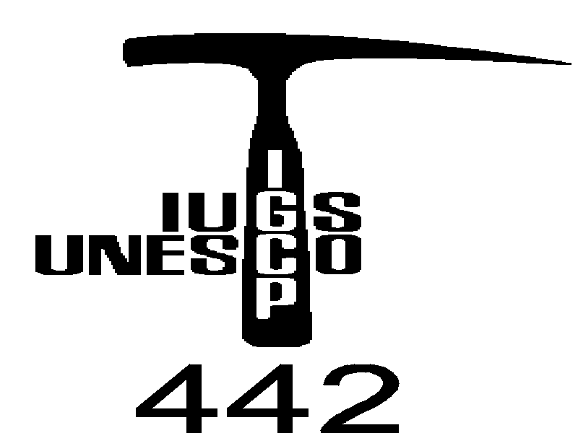

4th Workshop of the IGCP/UNESCO Project No. 442
"Raw materials of the Neolithic/ Aeneolithic polished stone artefacts:
their migration paths in Europe"

Third Circular

United Nations Educational, Scientific and Cultural Organization (UNESCO), International Union of Geological Sciences (IUGS), International Geological Correlation Programme (IGCP), Slovak Commission for UNESCO, The Slovak National Committee for IGCP/UNESCO programme
Organized with the collaboration of:
Museo Friulano di Storia Naturale – Udine,  Soprintendenza per i BAAAAS del Friuli Venezia Giulia – Udine,  Museo di Archeologia Ligure - Genova Pegli, | Soprintendenza ai Beni Archeologici della Liguria – Genova,  Ufficio per i Beni Archeologici - Provincia Autonoma di Trento,  Soprintendenza Speciale al Museo Nazionale “Pigorini” – Roma,

Meeting location
Udine and Genova, Italy, 24th – 28th September 2001

Lodging
Lodging in hotels during the workshop is covered by the Project budget.
Nights 24th and 25th September in Udine  Hotel Cristallo,  piazzale d’Annunzio 43, tel ++39 0432501919,  e-mail: info@cristallohotel.com  (see map) | Nights 26th, 27th and 28th September in Genova  Hotel Torre Cambiaso,  via Scarpanto 29 I- 16157, Tel. +39.010.665055, Fax +39.010.6973022, e-mail: info@torrecambiaso.com, www.torrecambiaso.com

Transport
Transport in term: 26-29/09/2001 (Udine-Genova-Udine) will be realised by bus. Participants which will come by car, they will left their cars in Udine.

Registration Fees
Participant who didn´t paid yet registration fee - we expect paiment of 40 USD (10 USD students) during registration in Udine

Program
September 24th, Monday, evening
Arrival to Udine. Accomodation. Night in Udine (Hotel Cristallo)
UDINE
SOCIETÀ FILOLOGICA FRIULANA
September 25th Thuesday
08.45 - Opening of the registration Office
09.15 - Opening of the workshop. Authorities Salutations
09.45 - Hovorka, D.: IGCP/UNESCO project 442 in its third year: history and future activities
10.15 - Coffee break*
10.30-13.00 - Relations, discussions.
10.30-10.45 Trnka, G.: Lower Bavarian Raw Materials along the River Danube to Eastern Austria.
10.45-11.00 Hovorka, D.: Where from are peculiar raw material types used in Neolithic on territory of nowadays Slovakia?
11.00-11.15 D’Amico C., Gasparotto G. & Sabetta T.: Chalcolithic hammer axes in NE Italy and Slovenija.
11.15-11.30 Prichystal, A. & Trnka G.: Raw materials of Lengyel polished artefacts from Kamegg and Strass in Lower Austria.
11.30–11.45 Spišiak, J. Hovorka, D. & Méres, Š.: High – pressure metabasites: peculiar raw material of Neolithic/Aeneolithic stone implements (Slovakia) and their supposed sources
11.45–12.00. Türkmenoğlu, A., Baysal, A., Toprak V. & Göncüoğlu M.C.: Raw Material Types of Groundstones >From Çatalhöyük Neolithic Site in Turkey
12.00-12.15 Christova-Anastasova E. & Pavúk J.: Die Felssteingeräte aus der neolithischen Tellsiedlung in Gălăbnik, Westbulgarien
12.15-12.30 Dominguez Bella, S., Cantalejo, P., Espejo, Mª.M. & Ramos Muñoz, J.: Lithic resources in the prehistoric societies of the III-II milleniums B.C. in the Rio Turon valley (Ardales, Málaga, Spain)
12.30-13.00 Discussion.
13.00 - Lunch *
14.30-17.00 - Relations, discussions.
14.30-14.45 Schléder, Zs., Biró, K. T. & Szakmány, Gy.: Neolithic Phonolite mine and workshop complex in Hungary.
14.45-15.00 Szakmány, Gy. & Kasztovszky, Zs.: Greenschist-amphibolite schist Neolithic polished stone tools in Hungary.
15.00-15.15 Józsa, S., Szakmány Gy., Oravecz H. & Csengeri P.: Petrography of blueschist stone tools in Hungary
15.15 15.30 T. Tezak-Greg & M. Buric: The polished stone implements of the neolithic Starcevo Culture in Northern Croatia.
15.30-15.45 Balen, J. Kurtanjek, D; & Balen, D.: Polished stone artefacts from Sopot culture site Samatovci in Slavonia region (Croatia)
15.45-16.00 Paunovic, M. & Maticec, D.: Origin and sources of raw material in Croatia
16.00-16.15 Thirault É.: The neolithic axe workshops of eclogites and jadeitites in the french Alps and Prealps and their role in the network of exchanges in the Rhône basin.
16.15-17.00 Discussion and verification of plans for the next year. Discussion and work on summarizing publications.
17.00 - Coffee break*
17.15-Pessina A., Starnini E. & D’Amico C.: Introduction to Neolithic and Copper Age Prehistory and Archaeopetrography in North-eastern Italy with particular attention to polished stone materials.
18.00 – Closing time
19.00 - Transfer to Pozzuolo, opening of an exhibition on Neolithic
20.30 - Dinner offered by the municipality of Pozzuolo del Friuli
September 26th, Wednesday
09.00 - D’Amico C.: A short picture of neolithic axes petrography.
09.30 - Examination of a selection of Neolithic polished stones of eastern-Italy collections: green stones from NW Italy, local volcanic and sedimentary lithologies, some danubian serpentinite, silexite etc. artefacts, as well as dacite axes possibly of eastern provenance; Copper Age axes made from serpentinite, metamorphic ultramafite, amphybolites etc. of eastern Alps – (Dinarides?) provenance. Discussion.
Examen PC and monitor aided of a number of thin sections of the exposed samples.
12.00 – Closing time
12.30 - Lunch *
*Lunch and coffee break are offered by Udine Museum and Municipality
13.30 - Trip to Genova by bus (6 hours).
Night in Genova. Hotel Torre Cambiaso
GENOVA
MUSEO DI ARCHEOLOGIA LIGURE DI GENOVA PEGLI
September 27th, Thursday
09.00 - Opening of the workshop.
Authorities Salutations (Assessore alla Cultura Pierantoni, Soprintendente Archeologo della Liguria Spadea, Direttore del DIPTERIS Albertelli, Presidente della Circoscrizione Maggi)
09.30 - Relations, discussion
D’Amico, C. & Starnini, E.: The polished stone axes workshop of Rivanazzano (PV-northern Italy): analyses of the lithological diversifies in comparison with other Italian Neolithic sites.
Prichystal, A.: Raw materials of polished artefacts from Bylany near Kutna Hora - key locality of Linear Pottery culture in Bohemia.
Illášová, L.: Alkali basalts – raw material of the Neolithic and Aeneolithic implements (Slovakia)
Meres, Š.Cheben, I. & Hovorka, D.: Site Bajc - bonanza of raw material types (Neolithic, Slovakia)
K.T. Biró: Towards a comprehensive project webpage for IGCP-442
Surmely, F., de Goër de Herve, A., Santallier, D. & d' Amico, C.: The distribution of axes in alpine metamorphic rocks (eclogites and jadeitites), in the central and southwest part of France
Gunia, P. & Prichystal, A.: Magnetic properties of Lower Silesian serpentinites and some serpentinite artefacts from SW Poland and Moravia.
Gunia, P. & Cholewa, P.: Serpentinites occurring of SW Poland as as potential raw material for production of the Neolithic artefacts
Discussion and verification of plans for the next year.
11.00 Coffee Break
Luciano Cortesogno – Geological - Introduction to the Ligurian HP metaophiolites.
Tiziano Mannoni - Use of HP metaophiolites by neolithic man
Roberto Ambra, Marco Firpo, Patrizia Garibaldi, Eugenia Isetti, Irene Molinari, Guido Rossi, Agostino Ramella – The state of Archaeological and Geological research in: Sassello area, Ligurian Appenine, and the Caves of western Liguria
Monique Ricq De Bouard - Stone axes of Ligurian origin found in mediterranean France
E. Thirault - Informations about Neolithic raw materials in Rhone Valley and French occidental Alps
13.30 Lunch in the Circoscritional House, near the Museum (offered by the Museum)
In the Afternoon,
Visit to the Museum.
Examen of Neolithic materials, in presence of students, who studied them and the provenante sites.
Observations and discussion
September, 28th, Friday
8.30 Departure from Pegli
10.00 Arrival to Sassello and excursion to eclogite and conglomerate outcrops (leaders Marco Firpo and Gianpaolo Dabove)
12.30 Fast food in Sassello (offered by the Sassello Municipalit)
14.00 Departure to Borgo Verezzi
16.00 Walk to the important site Grotta delle Arene Candide
16.00 Visit to the Caves, leading Roberto Maggi
18.45 Return to Pegli
Night in Genova. Hotel Torre Cambiaso
September 29th, Saturday
Morning (after breakfast) - trip to Udine by bus (6 hours) - departure of participants.
Prof. Dušan Hovorka, project leader
Department of Mineralogy and Petrology, Faculty of Natural Sciences - Comenius University, 842 15 Bratislava, Mlynská dolina, Slovak Republic

E-mail: meres@fns.uniba.sk
