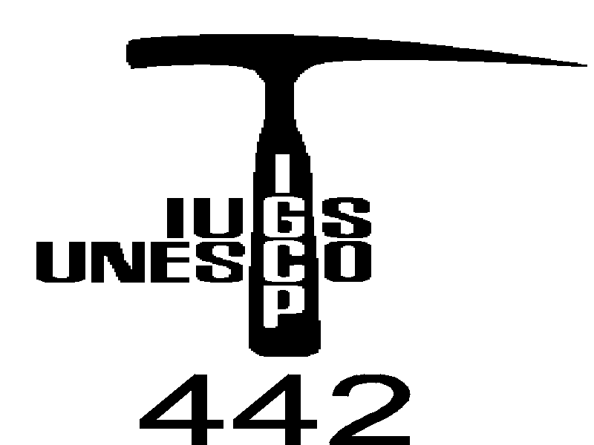First Circular

„Eggenburg 2000“

3rd Workshop Meeting of the IGCP/UNESCO Project No. 442:
"Raw materials of the Neolithic/Aeneolithic polished stone artefacts: their migration paths in Europe"
Eggenburg, Austria
27th – 29th September 2000
Meeting location
Eggenburg, Austria,
Accommodation
Accommodation will be reserved by organizer of the workshop on the base of your application
Lodging
Location of lodging and the meeting venue will be announced in the 2nd circular. Preliminary price is round 55 USD/night for 2 beds room.
Provisional programme
Arrival of participants, accommodation
Opening of session, presentation of obtained subproject results
More precise definition and approval of the working plans for next year
Appointment of the place and term of next meeting
Excursion
Important
Active participant of the Eggenburg 2000 we should offer financial help to cover part of traveling and lodging expences. We offer finnancial support also for those, who already published paper/papers deadling with the IGCP/UNESCO 442 Project and logo of the Project is printed in given paper. Weask for reprint! Supposed financial supply will be categorized according to the following hierarchy:
- review papers of the problematic of the IGCP/UNESCO 442 Project. Paper of this category should cover large territories or one theme (e.g. „Jadeitite-made implements in central Europe“). Extend: till 30 standard pages (tables, figrs., references included). Deadline: 27/09/2000 - delivery at Eggenburg 2000 presentation.
- Papers in frame of the IGCP/UNESCO 442 Project. Extend: 25 standard pages (incl. all enclosures and references). Deadline: 31/08/2000.
- Extended abstracts - 3 standard pages (no Figrs., no references) - we expect your accuracy in this respect! Deadline 20/06/2000. Book of abstracts will be ready till the Eggenburg 2000.

Manuscripts (ad.1 and 2)
Manuscript are limited to 25-30 pages (A4 paper, double-spaced, 2,5 margins, font size of 12 point). Manuscript should generally be organized in the following order: Title, Full name(s) and address(es), Abstract, Key words, Introduction, Conclusion, Acknowledgements, Appendix, References, Table and figure caption, Tables, Figures.
The title page - comprises the title of the paper, unabbreviated first names and surnames of the authors and their institutional adresses
Abstract - not exceeding 20 lines, should be informative and it should not contain references
Key words: (max. 7 items) should be in succession from general to specific ones
The text - consists of introduction, methods of study, experimental data, discussion and an acknowledgement (e. g. Grant Agency etc.). The main body of the text should be arranged under two or three levels of headings. Greek letters should be written in the margin in full (e. g. sigma). Hyphen should be carefully distinguished from dash. The authors shoud mark in the margin of the manuscript where tables and figures may be inserted.
References - the authors are cited in the text without the first names. Standard form is as follows:
Lucido, G. 1993: A new theory of the Earth continental crust. Geol. carpathica, 44, 2, 67-74.
Beránek, B., Leško, B. and Mayerová, M. 1979: Interpretation of seismic measurements along the trans-Carpathian profile K III. In: Babuška, V. and Plančár, J. (Eds.): Geodynamic investigation in Czecho-Slovakia. Veda, Bratislava, 1-232 (in Slovak).
Resume
Resume shold be approx. 30-40 lines. In resume citation on references, figrs and tables should be included. Resume we will translate to the Czech/Slovak language, which are asked by redactions of Czech as well as Slovak scientific Journals.
Tables - should be on separate sheet, they can not be included in the text. Title of tables ougth to be short . Number of tables should be limited to inevitable number.
Figures - all figures should be drawn in India ink only in a form suitable for reproduction. The maximal format of tables and figures is 19x12,5 cm. Authors are encouraged to sent the figuresd already reduced to the size desired for publishing. Colour figures are not accepted.
Manuscript on disk
Authors are asked to submit papers together with the hard-copy also in electronic form processed by IBM compatible computers. Only 3,5“ disks are accepted. Preferred formats for text is MS WORD and for graphics are BMP, PCX and CDR.

Papers and Extended abstracts send please by post and by E-mail on the address:
Prof. Dušan Hovorka, Department of Mineralogy and Petrology, Faculty of Natural Sciences - Comenius University, 842 15 Bratislava, Mlynská dolina, Slovak Republic

E-mail: dubikova@fns.uniba.sk

ACCOMMODATION BOOKING FORM
„Eggenburg 2000“

3rd Workshop Meeting of the IGCP/UNESCO Project No. 442:

"Raw materials of the Neolithic/Aeneolithic polished stone artefacts: their migration paths in Europe"
Eggenburg, Austria, September 27th – 29th 2000
Please Reserve for (Mr./Mrs., Name):

Address:

Telephone:
Fax:
E-mail:
Arrival Date: | Estimated time of Arrival:
Departure Date: | Estimated time of Departure:
"
This ACCOMMODATION BOOKING FORM should be delivered (post letter, E-mail, fax) to the project leader:
Prof. Dušan Hovorka, Department of Mineralogy and Petrology, Faculty of Natural Sciences - Comenius University, 842 15 Bratislava, Mlynská dolina, Slovak Republic,
Fax: 00421 7 60296 293, E-mail: dubikova@fns.uniba.sk
and project coleader:
Prof. Dr. Gerhard Trnka, Institut für Ur- und Frühgeschichte, Universität Wien, Franz Klein Gasse 1, A-1190, Vienna, Austria,
Telefax: +43-1-42779404, E-mail: Gerhard.Trnka@univie.ac.at
Deadline: april 30th 2000
REGISTRIATION FORM
„Eggenburg 2000“

3rd Workshop Meeting of the IGCP/UNESCO Project No. 442:

"Raw materials of the Neolithic/Aeneolithic polished stone artefacts: their migration paths in Europe"
Eggenburg, Austria, September 27th – 29th 2000
Surname:
First name:
Full contact adress:

E-mail:
Fax:
I will send review paper | yes | no
I will send paper | yes | no
I will send extended abstract | yes | no
I will present oral communication | yes | no
I will apply for financial suport | yes | no
Author(s) and title:

"
This REGISTRIATION FORM should be delivered (post letter, E-mail, fax) to the project leader:
Prof. Dušan Hovorka, Department of Mineralogy and Petrology, Faculty of Natural Sciences - Comenius University, 842 15 Bratislava, Mlynská dolina, Slovak Republic,
Fax: 00421 7 60296 293, e-mail: dubikova@fns.uniba.sk
and project coleader:
Prof. Dr. Gerhard Trnka, Institut für Ur- und Frühgeschichte, Universität Wien, Franz Klein Gasse 1, A-1190, Vienna, Austria,
Telefax: +43-1-42779404, e-mail: Gerhard.Trnka@univie.ac.at
Deadline: april 30th 2000

